**Game Design Procedure**

* Considering Mario Escape Game

**Steps:**

1. **World Size Definition:**

First define the world ( that how you break the screen under consideration ).

In this game, I have broken screen into 100 by 100 units,

using gluortho2d(0,100,0,100).

1. **Map Design ( Background Design):**

After world definition, firstly design background for your game.

In this case, background includes the following elements:

* 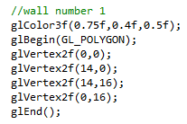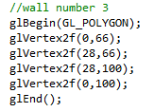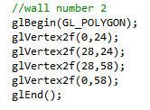**Walls :** To determine the available position for Mario and Bhoots to move across the world.
* 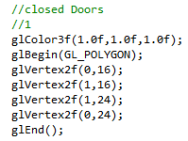**Closed doors :** To determine no-exit route for the Mario.

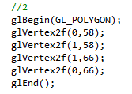

* **In door :** Determine the starting route or door for Mario to enter the world.
* **Out door :** Determine the Escape or Finish line for the Mario to win the game.
* **Routes :** Determine the routes on which the Mario can move throughout the world.
* For routes definition, Consider route #1, on that route, Mario can only move in upward and downward direction, so its one value is fixed, i.e its horizontal value, so we gave it a limit with min and max value i.e the vertical range within which it is said to be in route 1, if it cross the max or min limit, it will then move to the next route, in this case, if Mario exceeds the max_limit, it will be moved to route 2. Also, right left movement is disabled at route #1.

* Furthermore, Consider route #2, on that route, Mario can only move in horizontal directions, so its vertical value is fixed to a certain value, and given a max and min limit for horizontal movement. Also up and downward movement is disable except that points where it can exit route 2 and enter other routes, that are R1, R4, R3 and R7.

* **Controls:**

A => move left

D => move right

W => move up

S => move down

R => reset game

**Figure :**  Background design

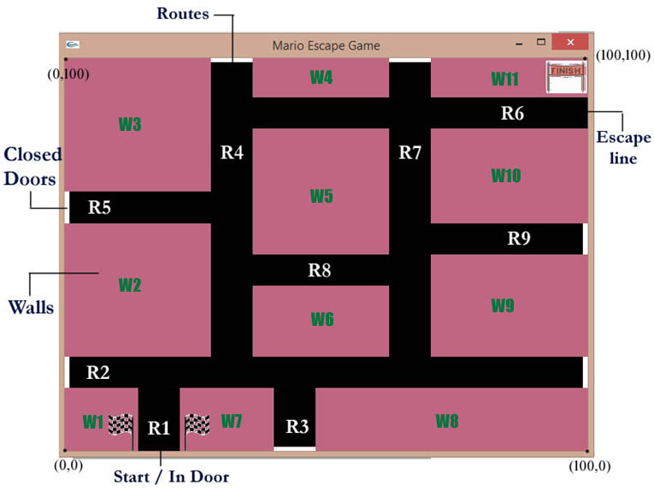

1. **Foreground Design:**

In this step, you have to elements which have main role in the scene or game.

In this case, Bhoots and Mario creation are the part of this step.

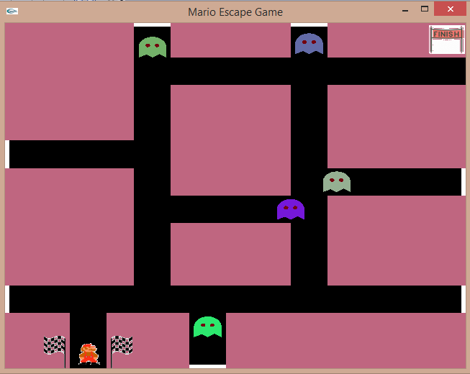

At this stage, bhoots and Mario are drawn on the screen but stay still on a fixed position. Movement of these element covers in the next step.

1. **Animations:**

At this stage, Animations are added to the foreground or background elements. In this case, animation includes walking of bhoots on different routes with different velocities. Also movement of Mario in the world include in this step.

For Example :

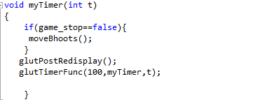

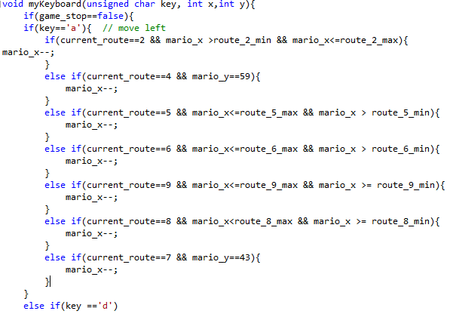

1. **Flags :**

This step include placing flags for different events, like in this game, checking for GameOver (if Mario collide with any of the bhoots ), checking for Win ( if Mario crossed the finish line without having clash with any of the bhoots ).

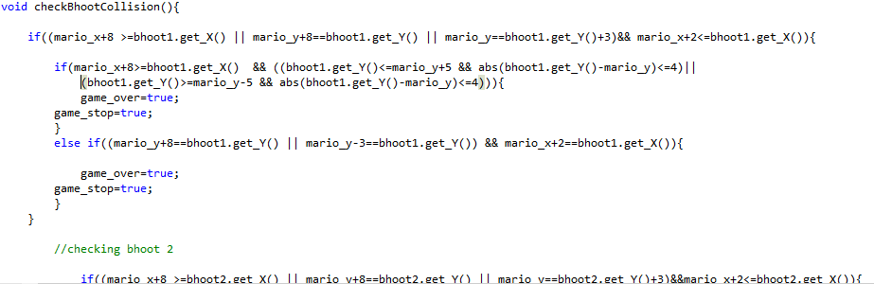

1. **Collision Detection :**

This step include checking whether the Mario collide with any of the bhoots or not. For this purpose, we check Mario’s x and y with addition of some offsets (because of mario’s width and height) that whether they are matching with bhoots axis or not (checking using Timer function). If any of bhoot’s axis collide with Mario’s axis, game will be stopped and Game Over image floats on the screen.

**Flow Chart**

